Sophia Ardell

Computational Physics

Tuesday, October 6, 2015

Homework Set #5

**Problem 1**

This problem evaluates the period of pendulum after being released from being held at an angle $θ_{0}$. This was evaluated was for various $θ_{0}$ up to $\frac{π}{2}$. I decided this was a good $θ_{max}$ since if the pendulum started at a greater $θ_{0}$, the tension acting on it would be 0, and thus it would not behave in the same manner. The function creates an Integrand object that has an alterable $θ_{0}$, with an operator that returns the function to be integrated, which is within the following function:

$$T= 2^{3/{2 }} \sqrt{\frac{l}{g}} \int_{0}^{θ_{0}}{\frac{dθ}{{(cos{θ}-\cos{θ_{0})}}^{1/2}}}$$

The coefficients were ignored for the calculation of the integral. The function cannot be evaluated at its upper bound, so I used Midsqu, which takes the midpoint rule exclusive of the upper bound. The midpoint object is then integrated using qromo. This process is repeated for incrementing values of $θ_{0}$ from 0.01 rad up to $\frac{π}{2}$, in intervals of 0.01 rad. Given that

$$T_{0}= 2π\sqrt{\frac{l}{g}}$$

and I needed to graph $\frac{T}{T_{0}}$, each integral was multiplied by ${\sqrt{2}}/π$, making them the actual ratio value. The graph is as follows:

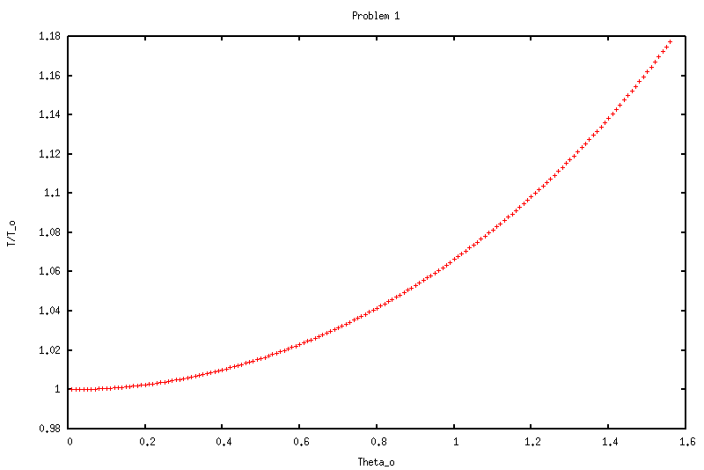

**Problem 2**

For this problem, I needed to evaluate the integral

$$I= \iint{e^{-xsiny}} dxdy$$

Over the interior of an ellipse whose boundary is given by

$$5x^{2}-6xy+5y^{2}=2$$

to an accuracy of 1 part in 108. Because Numerical Recipes integral functions return numbers (instead of functions) and *I* is a double integral, I needed to make two structs. A double integral works by holding the outside variable constant while evaluating the inner integral. Therefore when calling qromb on the entire function, it triggers a call for the current y value to be held constant while the inner integral is evaluated based on bounds that are dependent on the current y value. This repeats for the entire double integral (as y varied through its limits of integration).

I found the limits of integration for the inner integral by evaluating the boundary condition. I used completing the sqare. This gave:

$$x_{\max{/}min}= \frac{-3}{5} y ± \frac{1}{5}\sqrt{10-16y^{2}}$$

From this, it was clear that this function would only work if the term inside the square root was not negative, keeping the equation real. Therefore, I did the following operation to find the limits of the y value:

$$10=16y^{2}→y_{\max{/}min}= ±\sqrt{\frac{5}{8}}$$

The limits of integration for the outer integral need to be slightly altered since the actual bounds cannot be evaluated. I added 1-12 to each value as result.

The integrand was evaluated a total of 2,228,241 times. The computed integral was: 1.4490264.